**DEPARTMENT OF COMPUTER & SOFTWARE ENGINEERING**

**COLLEGE OF E&ME, NUST, RAWALPINDI**

AI & Decision Support Systems

Lab Report #3

**Student Name: Nawab Aarij Imam**

**Degree/ Syndicate: 43 CE - A**

**Task1:**

**Code:**

def bfs(self, start):

visited = set()

queue = deque([start])

order = []

while queue:

vertex = queue.popleft()

if vertex not in visited:

visited.add(vertex)

order.append(vertex)

for neighbor in self.graph[vertex]:

if neighbor not in visited:

queue.append(neighbor)

return order

graph = UndirectedGraph()

for vertex in ['A', 'B', 'C', 'D', 'E']:

graph.add_vertex(vertex)

edges = [

('A', 'B'), ('A', 'D'), ('A', 'E'),

('B', 'E'), ('B', 'D'),

('D', 'C')

]

for edge in edges:

graph.add_edge(edge[0], edge[1])

graph.print_graph()

print(graph.bfs('C'))

**Output:**

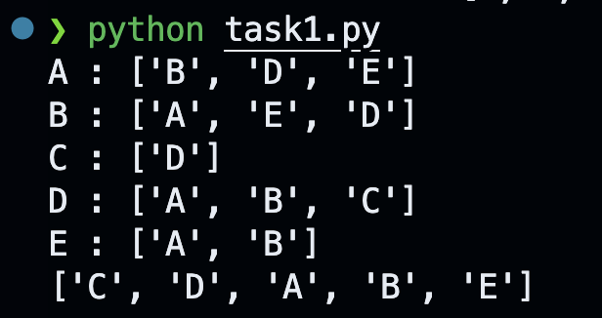

**Task2:**

**Code:**

from collections import deque

class Tree:

def __init__(self, data=None):

self.data = data

self.left = None

self.middle = None

self.right = None

def bfs(root):

if root is None:

return []

queue = deque([root])

order = []

while queue:

current_node = queue.popleft()

order.append(current_node.data)

if current_node.left:

queue.append(current_node.left)

if current_node.middle:

queue.append(current_node.middle)

if current_node.right:

queue.append(current_node.right)

return order

root = Tree(1)

root.left = Tree(2)

root.middle = Tree(3)

root.right = Tree(4)

root.left.left = Tree(5)

root.left.right = Tree(6)

root.right.left = Tree(7)

root.right.right = Tree(8)

root.left.left.left = Tree(9)

root.left.left.right = Tree(10)

root.right.left.left = Tree(11)

root.right.left.right = Tree(12)

bfs_result = bfs(root)

print("BFS Traversal Order:", bfs_result)

**Output:**



**Task3:**

**Code:**

from collections import deque

def shortest_path_bfs(maze):

if not maze or not maze[0]:

return -1

rows, cols = len(maze), len(maze[0])

directions = [(0, 1), (0, -1), (1, 0), (-1, 0)]

queue = deque([(0, 0, 0)])

visited = set((0, 0))

while queue:

row, col, distance = queue.popleft()

if row == rows - 1 and col == cols - 1:

return distance

for dr, dc in directions:

new_row, new_col = row + dr, col + dc

if 0 <= new_row < rows and 0 <= new_col < cols and maze[new_row][new_col] == 0 and (new_row, new_col) not in visited:

visited.add((new_row, new_col))

queue.append((new_row, new_col, distance + 1))

return -1

if __name__ == "__main__":

maze = [

[0, 1, 0, 0, 0],

[0, 1, 0, 1, 0],

[0, 0, 0, 1, 0],

[0, 1, 1, 0, 0],

[0, 0, 0, 0, 0]

]

# Find the shortest path

result = shortest_path_bfs(maze)

print("Shortest path length:", result)

**Output:**

